**CTS DIGITAL NURTURE - 4.0 JAVA FSE**

**WEEK 2 -TDD using JUnit5 and Mockito**

**1. JUnit_Basic Testing Exercises**

MANDATORY HANDS-ON 1:

QUESTION:

**Exercise 1: Setting Up JUnit**

**Scenario: You need to set up JUnit in your Java project to start writing unit tests. Steps: 1. Create a new Java project in your IDE (e.g., IntelliJ IDEA, Eclipse). 2. Add JUnit dependency to your project. If you are using Maven, add the following to your pom.xml: junit junit 4.13.2 test 3. Create a new test class in your project.**

PROGRAM:

**Calculator.java**

package com.example.junitdemo;

public class Calculator {

public int add(int a, int b) {

return a + b;

}

}

**CalculatorTest.java**

package com.example.junitdemo;

import static org.junit.Assert.*;

import org.junit.Test;

public class CalculatorTest {

*@Test*

public void testAdd() {

Calculator calc = new Calculator();

*assertEquals*(8, calc.add(5, 3));

}

}

OUTPUT:

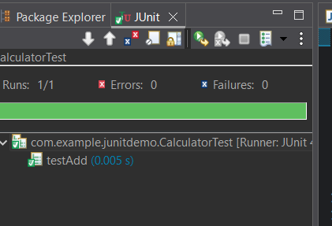

**Exercise 3: Assertions in Junit**

**Scenario: You need to use different assertions in JUnit to validate your test results. Steps: 1. Write tests using various JUnit assertions**

PROGRAM:

package com.example.junitdemo;

import org.junit.Test;

import static org.junit.Assert.*;

public class AssertionTest {

*@Test*

public void testAssertions() {

*assertEquals*(5, 2 + 3);

*assertTrue*(5 > 3);

*assertFalse*(5 < 3);

*assertNull*(null);

*assertNotNull*(new Object());

}

}

OUTPUT:

